**SYNOPSIS**

**On**

“Smart Canteen”

**MCA113-MINI PROJECT**

By

“Piyush Kulbhushan Adake” “3123015010194”

**Mini Project work carried out at**

**Faculty of Commerce and Management**



**VISHWAKARMA UNIVERSITY PUNE**

September 2023

## Vishwakarma University, Pune First Semester 2023-2024 MCA113-Mini Project Outline

|  |  |
| --- | --- |
| **SRN:** | **31231586** |
| **NAME OF THE STUDENT:** | **Piyush Kulbhushan Adake** |
| **Course Code:** | **MCA113** |
| **Course Name:** | **Mini Project** |
| **Mini Project Title:** | **Smart Canteen** |

# INDEX

1. Background
2. About The Project
   * Introduction
   * Existing System
   * Limitation of Existing System
3. Objectives & Key Goals
4. Proposed System
5. Scope Of Project
6. Tools Or Platforms
7. Hardware & Software Requirements
8. System Design
9. Data Flow Diagram
10. Entity Relationship Diagram
11. Database Design
12. Modules Use In Project
13. List Of Reports
14. Plan Of Work
15. Future Scope
16. References
17. **Background :-**

## Purpose and Goals:

Clearly define the purpose and goals of the smart canteen website project. This could include improving the dining experience, enhancing efficiency in food

ordering and delivery, promoting healthy eating habits, reducing food waste, or integrating technology for a seamless user experience.

## Target Audience:

Identify the target audience for the smart canteen website. This could include employees in a workplace, students on a campus, or visitors at a public facility.

Understanding the needs and preferences of the target audience will help in designing a website that caters to their specific requirements.

## Design and User Interface:

Create a visually appealing and user-friendly design for the website. Consider using a modern and clean design with intuitive navigation. Use colors, fonts, and images that align with the branding and overall theme of the smart

canteen project

## Reducing Food Waste:

The objective could be to implement features that allow users to customize portion sizes, track food availability in real-time, and offer incentives for

reducing food waste.

1. **About The Project:-**

**Introduction:**

In a world that is constantly evolving, where technology has become an integral part of our daily lives, it's only fitting that we apply these innovations to enhance our everyday experiences. The Smart Canteen Project is a groundbreaking initiative that aims to revolutionize the way we dine, bringing a fusion of cutting-edge technology and culinary excellence to the heart of our dining experience.

Imagine a dining environment where the traditional cafeteria or canteen is transformed into a hub of innovation, where every aspect of the dining process is optimized for efficiency, convenience, and sustainability. This is precisely what the Smart Canteen Project sets out to achieve.

**Existing System:**

The existing system for a Smart Canteen Project can vary depending on the specific goals and requirements of the project. However, here are some common components and features that may be part of an existing system or traditional cafeteria/canteen setup:

Manual Ordering: In many traditional canteens, customers place their orders by physically visiting a counter, selecting items from a menu board, and interacting with cafeteria staff.

Cash Payments: Payment is typically made in cash or with physical payment methods like credit/debit cards. Cashiers handle transactions, and customers receive printed receipts.

Static Menus: Traditional canteens often have fixed menus that change infrequently. These menus are typically displayed on menu boards or printed menus.

Food Preparation: Food is prepared by kitchen staff based on orders received at the counter. The cooking process may not always be optimized for efficiency or sustainability.

Limited Information: Customers may have limited access to nutritional information or ingredient details, making it challenging to make informed dietary choices.

**Limitation Of Existing System:**

The limitations of the existing system for a Smart Canteen Project highlight the need for modernization and the implementation of advanced technologies. Here are some common limitations of traditional canteen systems:

Inefficiency: Traditional canteens often suffer from inefficiencies in the ordering and payment processes. Manual ordering and cash transactions can lead to long queues and wait times.

Limited Payment Options: Cash is the primary payment method in many canteens, which may not be convenient for all customers. Lack of digital payment options can deter tech-savvy customers.

Static Menus: Fixed menus with limited options can become monotonous, and they may not cater to changing dietary preferences, cultural diversity, or seasonal ingredients.

Waste Generation: Manual ordering and food preparation can result in overproduction and food waste, contributing to environmental concerns.

## Objectives :-

The main objective of the Project on Canteen Management System is to manage the details of Canteen, Employee, Item, Stock, Sales.

It manages all the information about Canteen, Customer, Sales, and Canteen. The project is totally built at administrative end and thus only the administrator is guaranteed the access.

The purpose of the project is to build an application program to reduce the manual work for managing the Canteen, Employee, Customer, and Item.

It tracks all the details about the Item, Stock, and Sales.

The objective of the smart canteen project is to revolutionize the traditional concept of canteens by incorporating smart technology and innovative solutions. The primary goal is to enhance the overall dining experience for customers while streamlining operations and improving efficiency.

One of the key objectives is to implement a cashless payment system within the canteen. By introducing smart cards or mobile payment options, customers can conveniently make transactions without the hassle of carrying cash. This not only reduces waiting times but also ensures a secure and seamless payment process.

Another objective is to introduce a digital menu system that provides real-time information about available food items, prices, and nutritional details. This empowers customers to make informed choices based on their dietary preferences or restrictions. Additionally, the digital menu system can be updated instantly, allowing for better management of food inventory and reducing wastage.

The smart canteen project also aims to incorporate IoT (Internet of Things) devices to monitor and control various aspects of the canteen. For example, temperature sensors can be installed to ensure food is stored and served at optimal conditions, reducing the risk of spoilage and maintaining food quality. IoT devices can also be used to monitor and manage energy consumption, leading to cost savings and a more sustainable operation.

.

1. **Proposed System:-**

The proposed system for a Smart Canteen Project is designed to overcome the limitations of the existing system and leverage modern technology to enhance the dining experience. Here are the key components and features of the proposed system:

* Digital Payment Options:

Customers can make cashless payments through the mobile app, using methods like credit/debit cards, mobile wallets, or prepaid accounts.

Payment integration ensures a quick and secure checkout process.

* Dynamic Digital Menus:

Menus are displayed digitally, allowing for real-time updates and customization.

Seasonal specials, dietary labels, and allergen information are prominently displayed to assist customers in making informed choices.

* Smart Food Preparation:

Automated cooking equipment and efficient food preparation processes are employed to minimize wait times and ensure consistent quality.

Kitchen operations are optimized for sustainability, including energy-efficient appliances and waste reduction practices.

* Nutritional Information and Dietary Guidance:

The mobile app provides detailed nutritional information for each menu item.

Dietary preferences and restrictions are taken into account, and the app can suggest suitable menu options.

* Waste Reduction and Sustainability:

Food waste is minimized through portion control and surplus food redistribution.

Sustainable practices, such as composting and recycling, are integrated into the system to reduce environmental impact.

## Scope of Work (to be done by the student independently):-

* + **Requirements Gathering:**

This involves understanding the specific needs and goals of the canteen, including features, functionalities, and user requirements for the website.

## Design and User Interface:

Creating an appealing and user-friendly design for the website, including wire framing, prototyping, and visual design.

## Menu Management:

Developing a system to manage and update the menu items, including categories, descriptions, prices, and availability.

## Ordering and Payment:

Implementing an online ordering system that allows users to select items, customize orders, and make payments securely.

## Admin Dashboard:

Developing an admin dashboard to manage orders, update menus, track inventory, and generate reports.

## Real-time Updates:

Providing real-time updates on order status, availability of items, and estimated delivery times.

## Feedback and Reviews:

Incorporating a feedback and review system to allow users to provide feedback on their experience and rate the food and service.

## Mobile Responsiveness:

Ensuring that the website is responsive and optimized for mobile devices to provide a seamless experience for users on different devices.

## Security and Privacy:

Implementing security measures to protect user data, including encryption, secure login, and compliance with data protection regulations.

## Tools or Platform :-

* **NetBeans IDE :**

NetBeans IDE is a free, open source, integrated development environment (IDE) that enables you to develop desktop, mobile and web applications. The IDE supports application development in various languages, including Java, HTML5, PHP and C++. The IDE provides integrated support for the complete development cycle, from project creation through debugging, profiling and deployment. The IDE runs on Windows, Linux, Mac OS X, and other UNIX-based systems.

The IDE provides comprehensive support for JDK 7 technologies and the most recent Java enhancements. It is the first IDE that provides support for JDK 7, Java EE 7, and JavaFX 2. The IDE fully supports Java EE using the latest standards for Java, XML, Web services, and SQL and fully supports the GlassFish Server, the reference implementation of Java EE.

## Java Development Kit (JDK):

Install the JDK on your system, as it is required to write and run Java code. We can download the JDK from the Oracle website and follow the installation instructions.

## MySQL Workbench:

MySQL Workbench is a visual tool for database design, development, and administration. It allows you to create and manage databases, tables, and queries.

1. **Hardware and Software requirements :-**

# Software requirements-

## Operating System :-

Windows 7 or newer, macOS X v10.7 or higher, or Linux (Ubuntu).

## Java Development Kit (JDK):

Install the latest version of JDK, which includes the Java Runtime Environment (JRE) needed to run Java applications.

## Web Server:

We will need a web server to deploy your Java web application. Popular options include Apache Tomcat, Jetty, and GlassFish.

# Hardware requirements-

## Processor:

Minimum 1 GHz; Recommended 2 GHz or more

## Memory (RAM):

Minimum 2 GB; Recommended 4 GB or above

## Hard Drive :

Minimum 32 GB; Recommended 64 GB or more

1. **System Design :-**

# User Roles:

## Customers:

Users who browse the menu, place orders, make payments, and track their orders.

## Canteen Staff:

Users who manage the menu, process orders, update order status, and generate reports.

## Admin:

Users who have administrative privileges to manage user accounts, view analytics, and perform system maintenance.

# Functionalities:

## User Registration and Authentication:

Allow users to create accounts and authenticate themselves to access the application.

## Menu Management:

Enable canteen staff to add, update, and delete menu items, including their prices, descriptions, and availability.

## Order Placement:

Allow customers to browse the menu, select items, customize options, and add them to their cart.

## Payment Integration:

Integrate with a payment gateway to facilitate secure online payments.

## Order Processing:

Enable canteen staff to view and process incoming orders, update their status, and mark them as completed.

## Reporting and Analytics:

Generate reports for canteen staff and admins to analyze sales, popular items, and other relevant metrics.

## Feedback and Ratings:

Allow customers to provide feedback and ratings for their orders and overall canteen experience.

## Admin Dashboard:

Provide admins with a centralized dashboard to manage user accounts, monitor system performance, and perform administrative tasks.

## 9. Data Flow Diagram (DFD) :-

* + **0th Level DFD-**

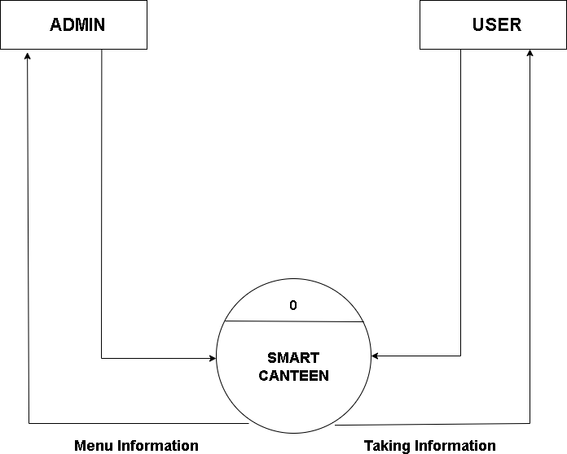

* + **1st level DFD-**

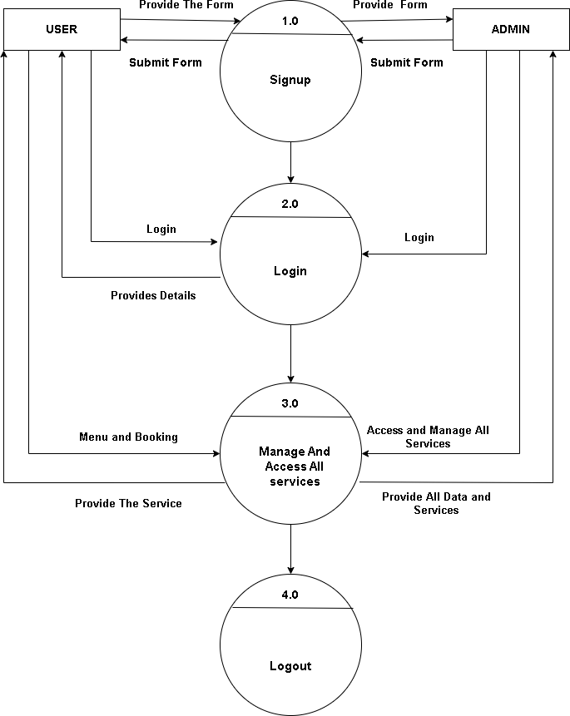

* + **2nd level DFD-**

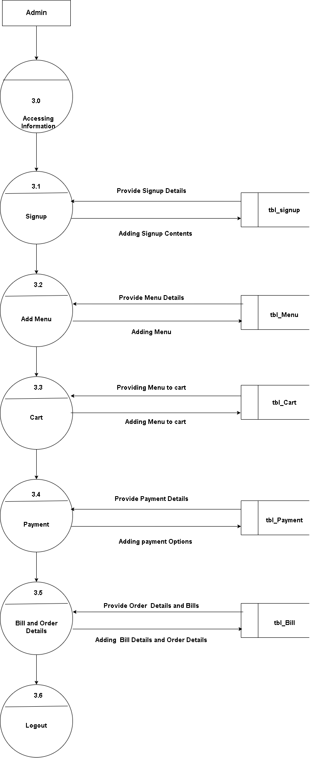

## 10. Entity Relationship Diagram (ERD) :-

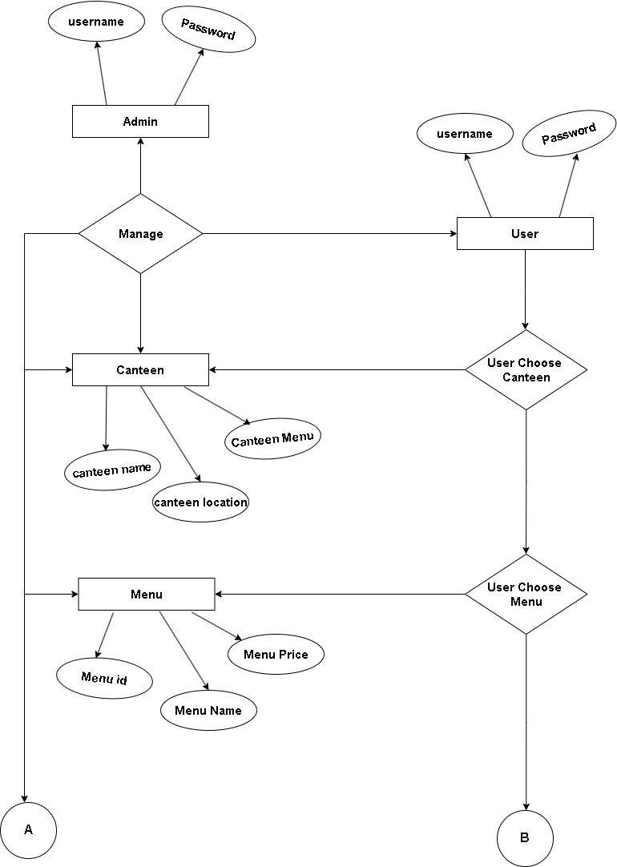

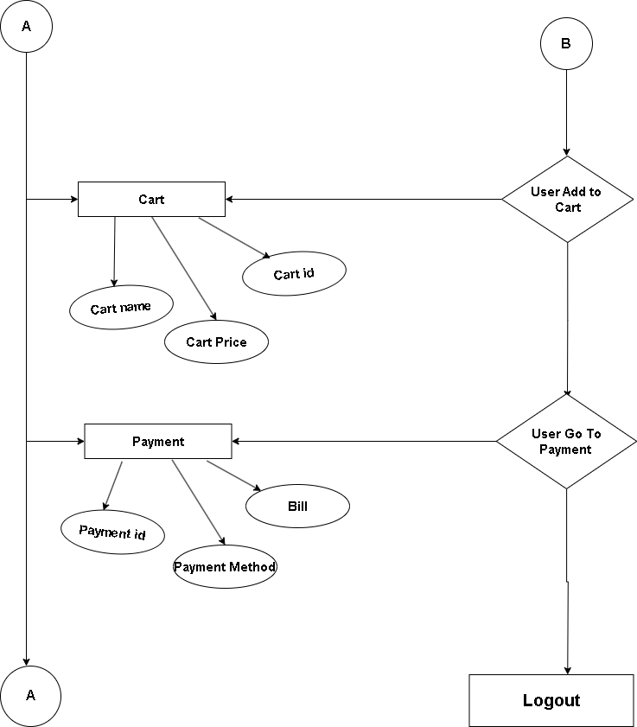

1. **Database Design :-**

## Identify Entities:

Start by identifying the main entities involved in the canteen system. Some common entities in a canteen project may include:

1. **Customers**: Information about the customers who visit the canteen.
2. **Menu Items**: Details about the food and beverages available in the canteen.
3. **Orders:** Information about the orders placed by customers.
4. **Employees:** Details about the canteen staff, such as chefs, waiters, etc.
5. **Suppliers:** Information about the suppliers who provide ingredients and other supplies to the canteen.
6. **Transactions:** Records of financial transactions, such as payments and invoices.

## Define Relationships:

* 1. Customers can place multiple orders.
  2. Orders can contain multiple menu items.
  3. Employees can be assigned to specific orders or shifts.
  4. Suppliers can provide ingredients for multiple menu items.

## Determine Attributes:

For each entity, identify the attributes or properties that need to be stored. For example:

* 1. **Customers:** Name, contact information, loyalty points, etc.
  2. **Menu Items:** Name, description, price, ingredients, etc.
  3. **Orders:** Order number, customer ID, order date, total amount, etc.
  4. **Employees:** Name, position, contact information, shift details, etc.
  5. **Suppliers:** Name, contact information, delivery schedule, etc.
  6. **Transactions:** Transaction ID, order ID, payment method, amount, etc.

## Design Tables and Fields:

Based on the identified entities and attributes, create tables in the database to store the data. Each table represents an entity, and each column represents an attribute. Define appropriate data types and constraints for each field.

For example, you might have tables like:

* 1. **Customers** (customer_id, name, contact_info, loyalty_points, ...)
  2. **Menu_Items** (item_id, name, description, price, ingredients, ...)
  3. **Orders** (order_id, customer_id, order_date, total_amount, ...)
  4. **Employees** (employee_id, name, position, contact_info, shift_details, ...)
  5. **Suppliers** (supplier_id, name, contact_info, delivery_schedule, ...)
  6. **Transactions** (transaction_id, order_id, payment_method, amount, ...)

## Modules Use in the Project :-

1. **User Management Module:**

This module handles user authentication, registration, and profile management. It allows users to create accounts, log in, and manage their personal information.

## Menu Management Module:

This module is responsible for managing the canteen menu. It allows administrators to add, edit, and delete menu items. It may also include features like categorizing items, setting prices, and managing availability.

## Order Management Module:

This module handles the process of placing and managing orders. It allows users to browse the menu, add items to their cart, and submit orders. It may also include features like order tracking, order history, and payment integration.

## Inventory Management Module:

This module tracks the inventory of ingredients and supplies in the canteen. It helps in managing stock levels, generating alerts for low stock, and updating inventory when orders are placed.

## Payment Module:

This module handles payment processing for orders. It integrates with payment gateways or other payment systems to securely process payments from customers.

## Reporting and Analytics Module:

This module provides insights and analytics about the canteen's operations. It may include features like generating sales reports, analyzing customer preferences, and tracking key performance indicators.

## Feedback and Rating Module:

This module allows customers to provide feedback and ratings for the food and service. It helps in improving the quality of the canteen's offerings and provides valuable insights for the management.

## Admin Dashboard Module:

This module provides a centralized interface for administrators to manage various aspects of the canteen system. It includes features like user management, menu management, order management, and reporting.

## List of Report :-

1. **Sales Report:**

This report provides an overview of the sales made in the canteen over a specific period. It includes information such as total sales, top-selling items, revenue by category, and trends in sales over time.

## Inventory Report:

This report provides information about the current stock levels of ingredients and supplies in the canteen. It helps in tracking inventory usage, identifying low stock items, and planning for restocking.

1. **Order Report:**

This report provides details about the orders placed by customers. It includes information such as order date, time, items ordered, customer details, and order status. This report can help in analysing order patterns, identifying popular items, and tracking order fulfilment.

## Customer Feedback Report:

This report compiles feedback and ratings provided by customers. It helps in understanding customer satisfaction levels, identifying areas for improvement, and tracking the performance of the canteen's offerings.

## Financial Report:

This report provides financial insights for the canteen. It includes information such as revenue, expenses, profit margins, and cost analysis. This report can help in monitoring the financial health of the canteen and making informed business decisions.

## Menu Analysis Report:

This report analyses the performance of menu items. It includes information such as popularity, profitability, and customer preferences for different items. This report can help in optimizing the menu and identifying opportunities for introducing new items.

## Staff Performance Report:

This report evaluates the performance of the canteen staff. It includes information such as attendance, punctuality, customer feedback, and productivity. This report can help in identifying training needs, recognizing top performers, and improving overall staff efficiency.

## Plan of Work :-

|  |  |  |  |
| --- | --- | --- | --- |
| **Sr. No** | **Description of Work** | **Start Date** | **End Date** |
| 1 | Study | 22/09/2023 | 25/009/2023 |
| 2 | Design | 26/09/2023 | 07/10/2023 |
| 3 | Development | 10/10/2023 | 10/11/2023 |
| 4 | Testing | 11/11/2023 | 25/11/2023 |
| 5 | Documentation | 26/11/2023 | 31/11/2023 |

1. **Future Scope the Project :-**

The future scope of smart canteens can encompass various advancements and enhancements. Here are some potential areas of future development for smart canteens:

## Integration of IoT (Internet of Things):

Smart canteens can leverage IoT technologies to connect various devices and systems, enabling seamless communication and automation. For example, IoT sensors can be used to monitor food temperature, track inventory levels, and optimize energy consumption.

## Mobile Ordering and Payment:

The future of smart canteens may involve the implementation of mobile apps or web-based platforms that allow customers to place orders, make payments, and receive notifications about their orders. This can enhance convenience and streamline the ordering process.

## Personalized Recommendations:

Smart canteens can utilize data analytics and machine learning algorithms to analyze customer preferences and provide personalized recommendations. By understanding individual preferences, the canteen can offer tailored menu suggestions and promotions to enhance customer satisfaction.

## Cashless Transactions:

With the increasing popularity of digital payment methods, smart canteens can adopt cashless payment systems such as mobile wallets, contactless cards, or QR code-based payments. This can improve transaction speed, security, and convenience for customers.

## Sustainability and Waste Reduction:

Future smart canteens may focus on implementing sustainable practices to reduce food waste and minimize environmental impact. This can include initiatives such as smart portion control, food waste tracking, and composting programs.

## Integration with Smart Campus Systems:

Smart canteens can be integrated with other smart campus systems, such as student ID cards, attendance systems, and campus navigation apps. This integration can provide a seamless experience for students and staff, allowing them to access canteen services using their existing campus credentials.

## Data-driven Decision Making:

By collecting and analyzing data on customer preferences, sales trends, and operational efficiency, smart canteens can make data-driven decisions to optimize menu offerings, pricing strategies, and resource allocation.

## Enhanced Customer Engagement:

Future smart canteens may focus on enhancing customer engagement through loyalty programs, personalized promotions, and interactive digital signage. This can help build stronger relationships with customers and encourage repeat visits.

## References :-

[**www.Google.com**](http://www.Google.com)

[**https://chat.openai.com**](https://chat.openai.com)

[**https://www.wikipedia.org**](https://www.wikipedia.org)

[**https://app.diagrams.net/**](https://app.diagrams.net/)

|  |  |
| --- | --- |
| **Signature of Student** | **Signature of Guide** |
| **Name Of the Student:** | **Name of the Guide:** |